Make the following change of units:
- VOLUME:

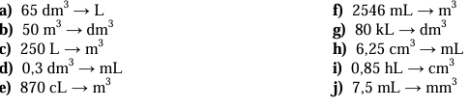

- TEMPERATURE:
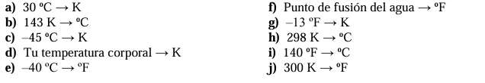

- PRESSURE:
Express the following units of pressure in S.I. units:
a) 1140 mmHg
b) 2,5 atm
c) 950 mbar
Make the following changes of units of pressure:
a) 3 atm → mmHg
b) 1200 mb → atm
c) 85000 Pa → mbar

